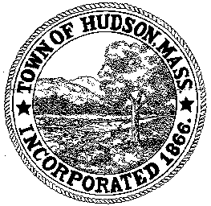

CONSERVATION COMMISSION
78 Main Street, Hudson, MA 01749
(978) 562-2020

Paul Byrne, Chairman W. Minot Wood, Vice Chairman David Esteves, Member

Terrence Joyce, Member Leif Longtine, Member Joseph Rodrigues, Member Al Tashian, Member

Meeting Agenda
May 5, 2011 7:00 P.M.

- Preliminaries
  - Open Meeting
  - Roll Call

2.0 New Business
2.1 RDA 405
Location: 108 Park Street
Applicant: Matthew Fasulo
Project Description: After-the-fact removal of dead trees overhanging the house

2.2 RDA 406
Location: 35 Temi Road
Applicant: Brian Hatfield
Project Description: Installation of a 24’ round above ground pool

2.3 Minutes April 7, 2011
2.4 Plantings at 8 Freeman
2.5 May 11, 2011 meeting re: 481 Main Street

3.0 Old Business

4.0 Correspondence

5.0 Adjournment:

Next Meeting: May 19, 2011

